**Coding Challenge**

**Question 2:**

Execute Pyspark -sparksql joins & Applying Functions in a Pandas DataFrame

**Joins**

**Two datafrmaes on which we will perform joins:**

**Inner Join:**

**Outer Join:**

**Left Join:**

**Right Join:**

**LeftSemi Join:**

**Leftanti Join:**

**Applying Functions in a Pandas DataFrame**

**Using apply():**

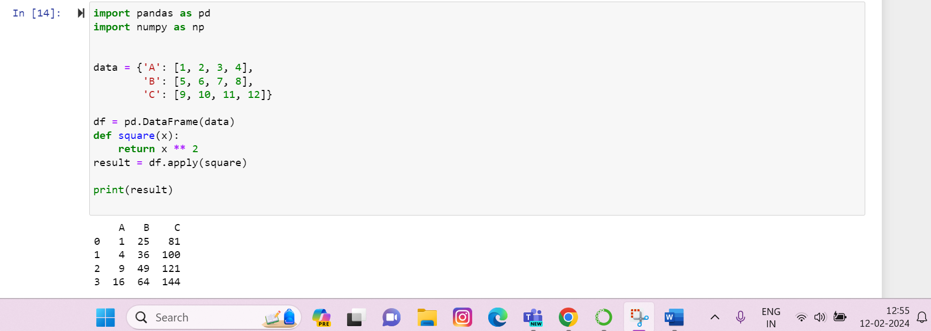

**Using axis() with apply():**

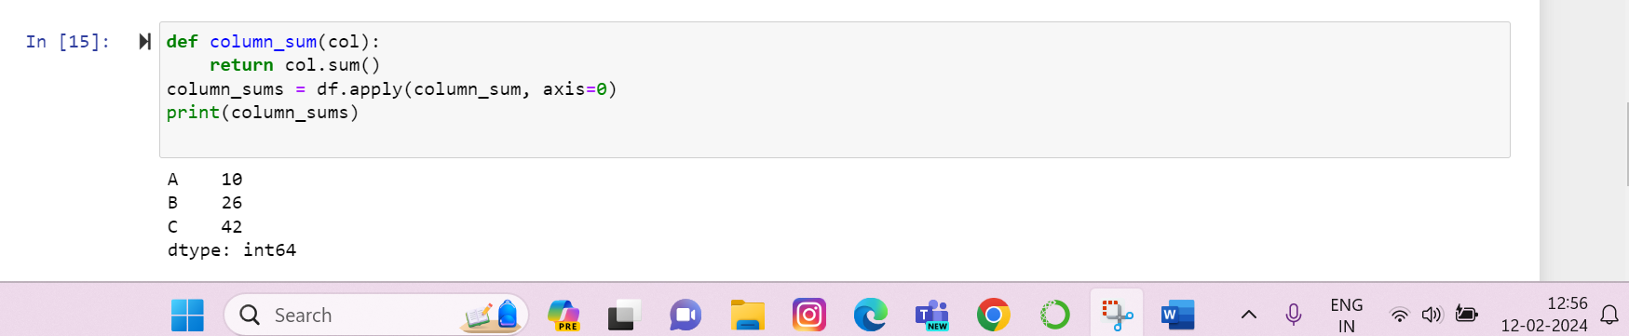

**----Continued Below----**

**Using lambda() with apply() and axis():**

